**RETAIL PRODUCT MANAGEMENT system**

**Project Abstract**

**Version 1.0**

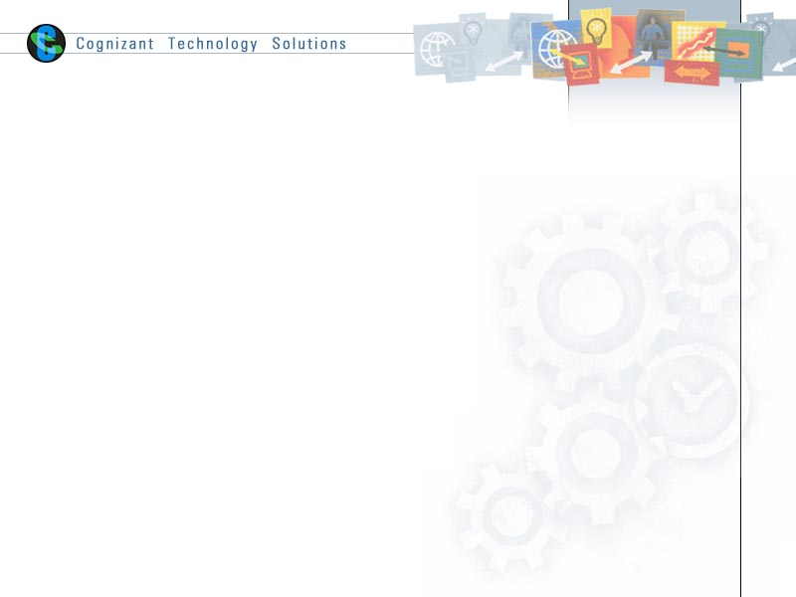

|  |  |  |  |
| --- | --- | --- | --- |
|  | Prepared By / Last Updated By | Reviewed by | Approved By |
| Name | Manish Shingare (2125636)  Dhriti Sinha (2125946)  Priyanka Jatav (2125801)  Himanshu Ranjan Singh (2125459)  Ashi Agarwal (2125257)  Prajwal NIrmal (2125331) | Trainer Name:  S. N. Rao | Trainer Name: S. N. Rao |
| Role | Manish Shingare (2125636)- POD Lead  Dhriti Sinha (2125946)- POD member  Priyanka Jatav (2125801)- POD member  Himanshu Ranjan Singh (2125459)-POD member  Ashi Agarwal (2125257)-POD member  Prajwal NIrmal (2125331)- POD member |  |  |
| Signature |  |  |  |
| Date | 27/06/2022 |  |  |

Table of Contents

1.0 Purpose of this document 4

2.0 Business Case 4

2.1 Abstract 4

2.2 Introduction 4

2.3 Problem Statement 5

2.4 Proposed Statement 5

2.5 Flow Chart 6

3.0 Appendices 7

3.1 Glossary 7

3.2 Other 7

4.0 Terms & Conditions 7

5.0 Change Log 7

# Purpose of this document

This document provides an overview about the Retail Product Management System and how it can be helpful in the technologically advancing world. The system is web-based application which manages customer’s and vendor’s data also Customer can purchase product online.

# Business Case

## Abstract

**E-commerce** (**electronic commerce**) is the activity of electronically buying or selling of products on online services or over the Internet. E-commerce draws on technologies such as mobile commerce, electronic funds transfer, supply chain management, Internet marketing, online transaction processing, electronic data interchange (EDI), inventory management systems, and automated data collection systems.

World’s first E-Commerce was built by Sequoia Data Corp. in 1989, It was a simple web-based system where sellers could post items for sale and buyers could search the database and make purchase.

One of the integral parts of E-Commerce business is Product Management system and if the retail product management system is introduced would result in significant betterment in country's day to day businesses and improvement in the relationship between customers and vendors. This could also lead to increase the transparency between customers and vendors.

This is an integrated service which provides all information about the products for customers. The proposed system is a cloud base application which provides information about type of product, price of product. This system manages customer’s feedback about services through its rating functionality. This system automatically manages and assign the vendors according to available product stocks. The customers also would be able to add the product to their cart to purchase, if available, or else customers can add respective product to their Wishlist.

## Introduction

This is an integrated service which provides all information about the products for customers. The proposed system is a cloud base application which provides information about type of product, price of product. This system manages customer’s feedback about services through its rating functionality. This system automatically manages and assign the vendors according to available product stocks. The customers also would be able to add the product to their cart to purchase, if available, or else customers can add respective product to their Wishlist.

The purpose of Retail Product Management System is to automate the existing manual system by the help of computerized equipment and full-fledged computer software, fulfilling their requirements, so that their product data/information can be stored for a longer period with easy accessing, for the purpose of, if any conflict between customer and vendor arises related to any product can be resolved on the basis of these information. The data can’t be manipulated or modified by either vendor or customer.

## Problem Statement

Traditionally, customer would go to retail shopping mart for purchasing the desired products and will consult the assistant for the location of items, also customer has to physically visit the respective racks where the product has been kept and according to customer’s requirement he/she has to put the items in the trolly and has to wait in long billing queues. This whole process of purchasing products manually could be a lot time consuming and hectic. So, the Retail Product Management system would play an important role to solve this very known problem of simply purchasing the goods, without wasting time and physical efforts.

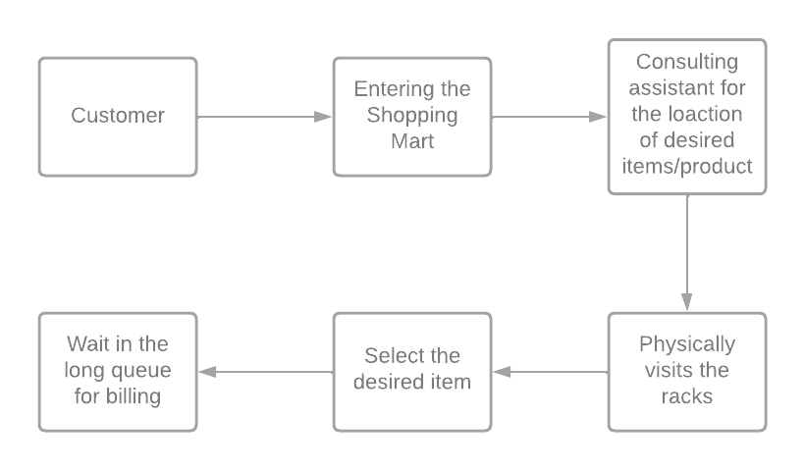

Fig 1.1 Existing System

## Proposed System

The proposed system is designed to eliminate the disadvantages of the existing system. The proposed system “Retail Product Management System” is mentioned for tracing the problems in the existing system.

* Increased efficiency, transparency and reliability.
* Easier Access.
* Easy to use.
* Provide accurate information to the customers for taking necessary decisions related to product.
* Efficiency - Information can be collected, processed, and communicated more quickly and efficiently. Systems ensure that right product reaches the right person at the right time.
* Accessibility, Usability and Understandability.
* The options used can be easily accessed, used, and realized.
* User can log in and search the product by Id or name .
* Users can view available products and other details like price etc.
* User can add products to the cart according to availability.
* If product is unavailable user can add that product into the Wishlist.
* User can also rate the purchased product to help other users.
* Product information cannot be lost.
* Product information cannot be stolen.

## Flow chart

Retail Product Management System contains the following implementation of modules.

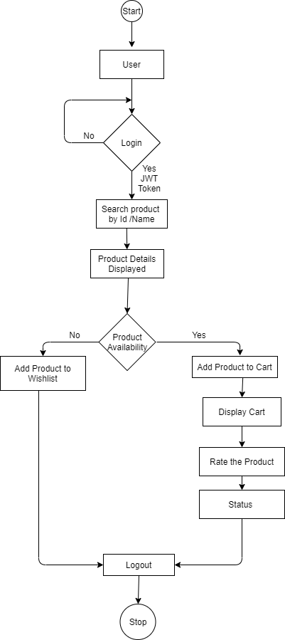

Fig. 1.2 Work Flow Diagram

# Appendices

## Glossary

|  |  |
| --- | --- |
| **Acronyms** | **Definitions** |
|  |  |

## Other

1. Terms & Conditions

***Disclaimer: Please do not circulate or distribute this document outside of Cognizant Network, we have a Zero Tolerance Policy. Kindly adhere to 100% Compliance at all times.***

# Change Log

*Please note that this table needs to be maintained even if a Configuration Management tool is used.*

|  |  |  |  |  |
| --- | --- | --- | --- | --- |
| Version Number | Changes made | | | |
| V<n.n> | *<If the change details are not explicitly documented in the table below, reference should be provided here>* | | | |
| Page no | Changed by | Effective date | Changes effected |
|  |  |  |  |
|  |  |  |  |
|  |  |  |  |
|  |  |  |  |